Set up a JSON server: to work with APIs

Install json-server: npm install –g json-server

If you want to create a file: json-server user.js

If will provide you a default file which we can edit.

{

  "users": [

    {

      "id": 1,

      "name": "sonam",

      "email": "sonam@gmail.com"

    },

    {

      "id": 2,

      "name": "alex",

      "email": "alex@microsoft.com"

    }

  ]

}

You can exit from json-server and start it again to check apis.

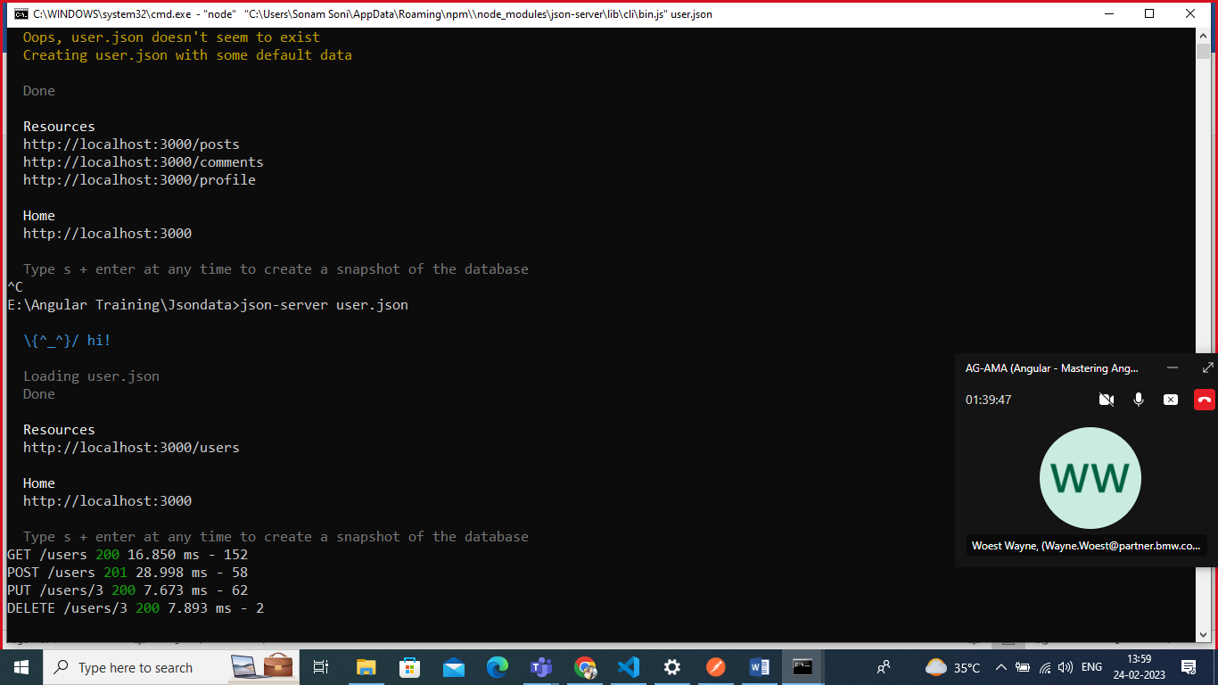

You can see it is showing <http://localhost:3000/users>

By default it will provide you a apis

<http://localhost:3000/users> : get method (which will return all data)

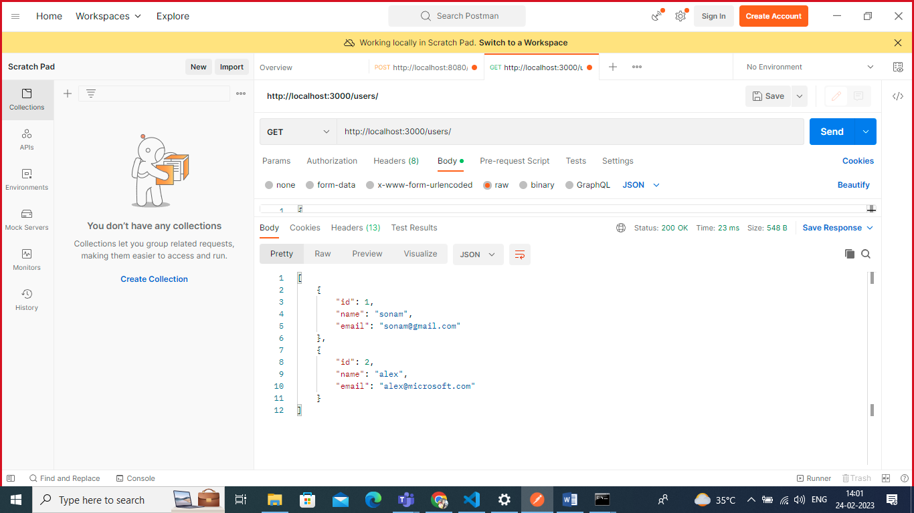

<http://localhost:3000/users/id> : get the value based on the ID

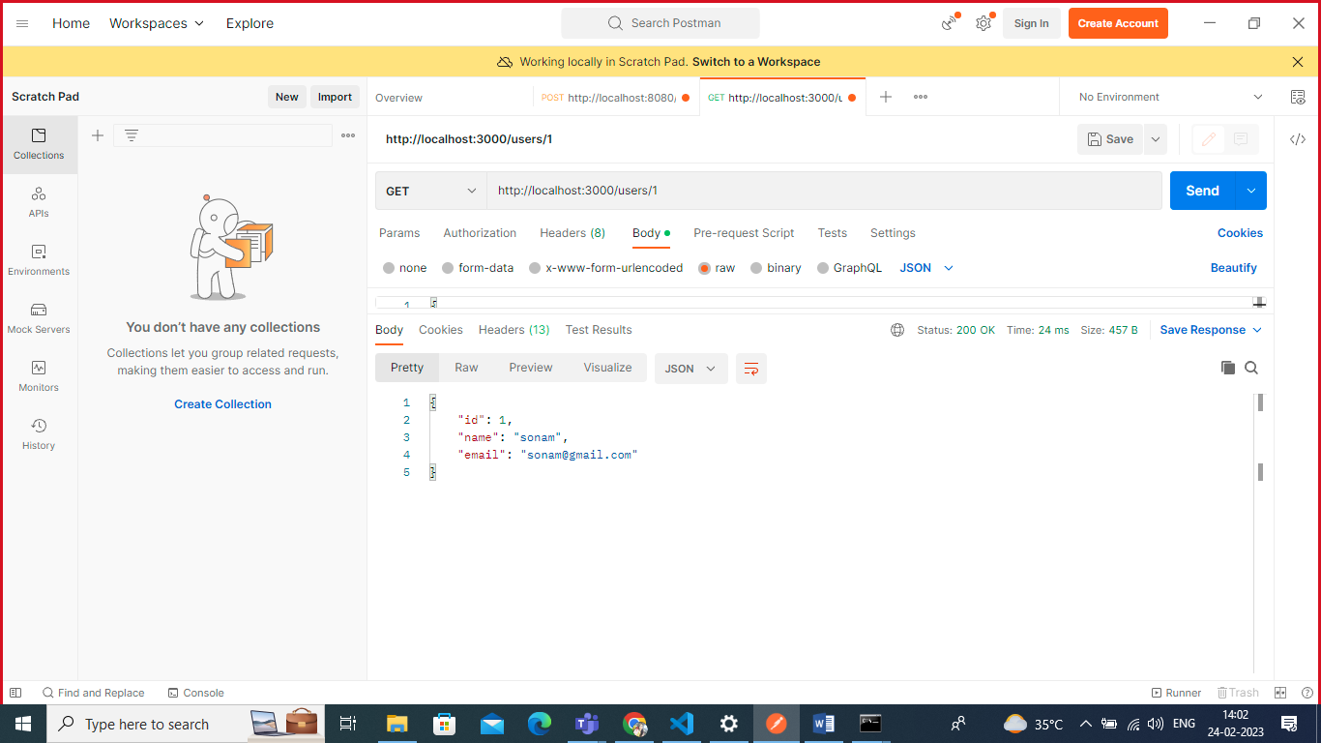

<http://localhost:3000/users> : post method post data

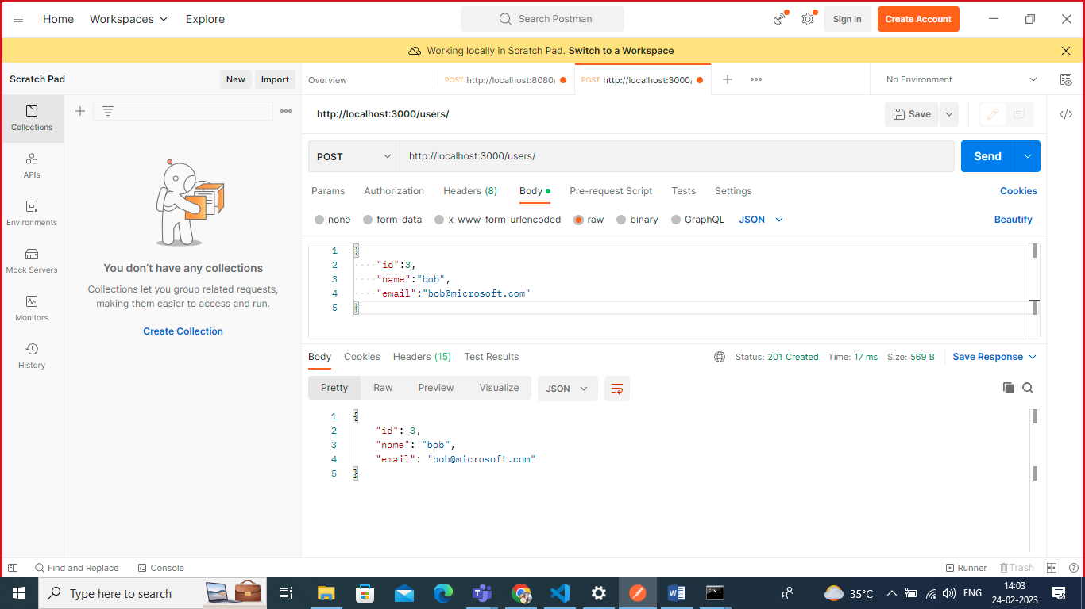

<http://localhost:3000/users/id> : put method update your data

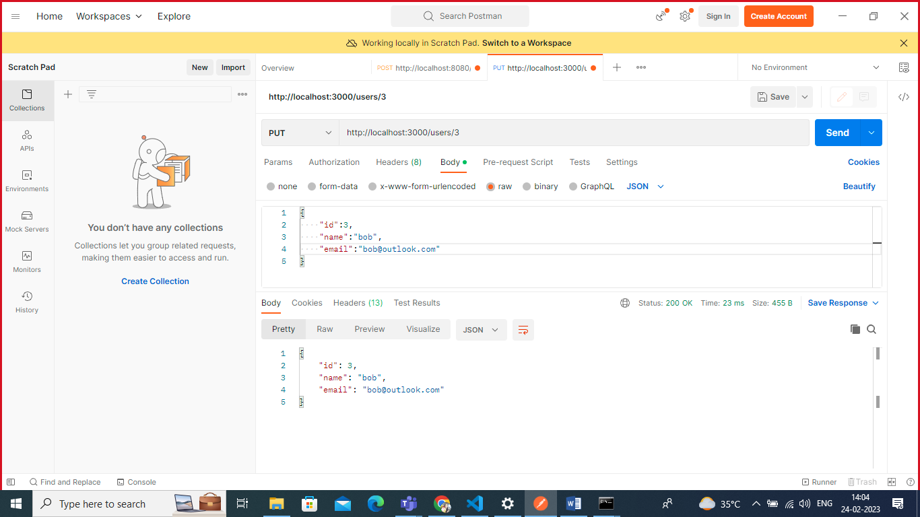

<http://localhost:3000/users/id> : patch method add single field

